Exercise: Modular Applications
The following tasks do not have tests in the Judge system. They are for practice.
Working with Remote Data
For the solution of some of the following tasks, you will need to use an up-to-date version of the local REST service, provided in the lesson’s resources archive. You can read the documentation here.

Team Manager
Create a JS application for managing teams.

Libraries
Use the page and lit-html libraries for routing and templating. Use npm install to install them, as they are included in package.json.

Data
Use the provided local REST service to store data and users. Note that there are some special access rules for this task – anyone can create a record in the requests collection, but only the team admin (team owner) can approve requests for membership. This check is provided automatically by the server, but you must implement front-end checks, in order to display the correct controls.
Users are stored similarly to previous tasks in this course, in the /users service. In this app, registration requires an extra field username , added along with the usual email and password.
Each user can be owner and member of multiple teams.
For the catalogue you can optionally implement pagination, or allow the user to scroll down infinitely while new data is being loaded (infinite scroller).

HTML & CSS
As usual you are provided with HTML and CSS. You may change the HTML by adding attributes, adding URL's where needed and so on as you see fit.

Application Requirements

Navbar
The application has a navigation bar, with links to other pages. You need to implement the visibility of the buttons in the header, depending on whether there is a logged-in user or a guest. This is how the header should look like for a guest user:
When there is a logged-in user, the header should look like this:
The "Browse Teams" button is always visible. The "Team Manager" is link to home page.

Home
Guest visitors see the "Sign Up Now" button, while logged-in users see the "Browse Teams" buttons.
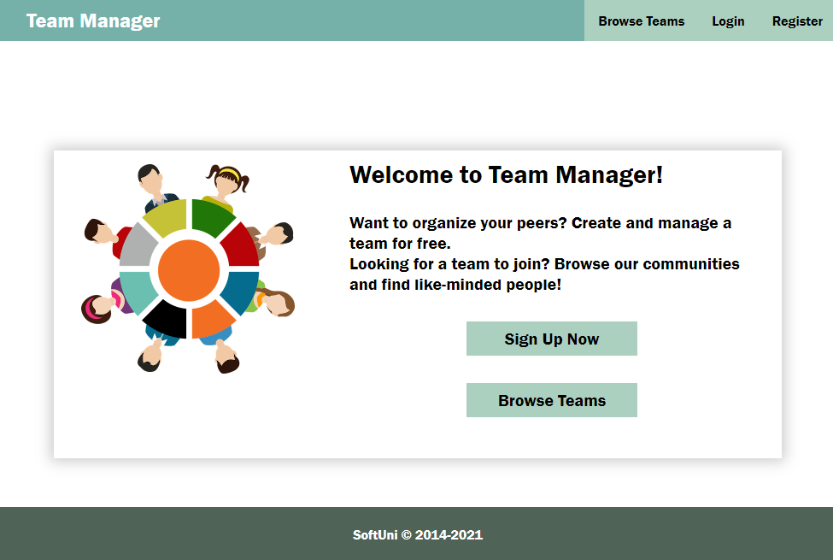

Browse Teams
Guest users can see a list of all teams. The button "Create Team" is not available for guest users.
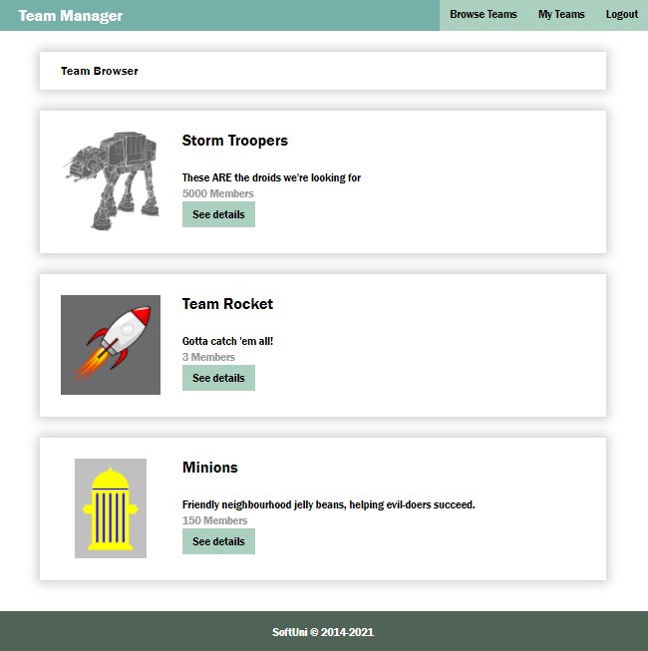
Logged in users can see the button "Create Team"
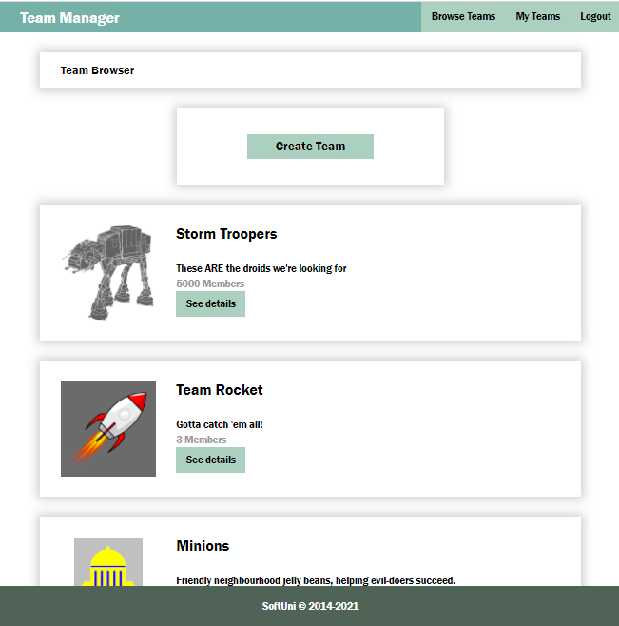
Use the following endpoints to obtain information from the service:
- List of all teams:
GET /data/teams
- List of all members:
GET /data/members?where=status%3D%22member%22
Once you have the list of all members, you need to process the list and count the members for every team. Note that the previous request will return all members in all teams. If you want to use pagination for the catalog (optional), you need to modify the query so that it only includes the members of teams currently on display:
- List of all members in particular teams (unencoded):
GET /data/members?where=teamId IN ("{id1}","{id2}","{id3}",…) AND status="member"
Where {id1}, {id2}, etc. is a list of comma-separated team Ids. Note that every Id must be in double quotes since object Ids are strings. To send this query, use the encodeURIComponent function on the query parameter value (the part after the first equal sign, beginning with teamId).

Register
You need to write the functionality for registration of new user. By clicking the "Register" button you have to load the registration form. When the "Create Account" button of the form is clicked you need to send a post request to register the new user. The fields by registration have validations as follows:
- e-mail: required, valid e-mail;
- username: required, at least 3 characters;
- password: required, at least 3 characters/digits.
If there is a validation error you need to show the div with class "error" to visualize the message, otherwise the div is not displayed.
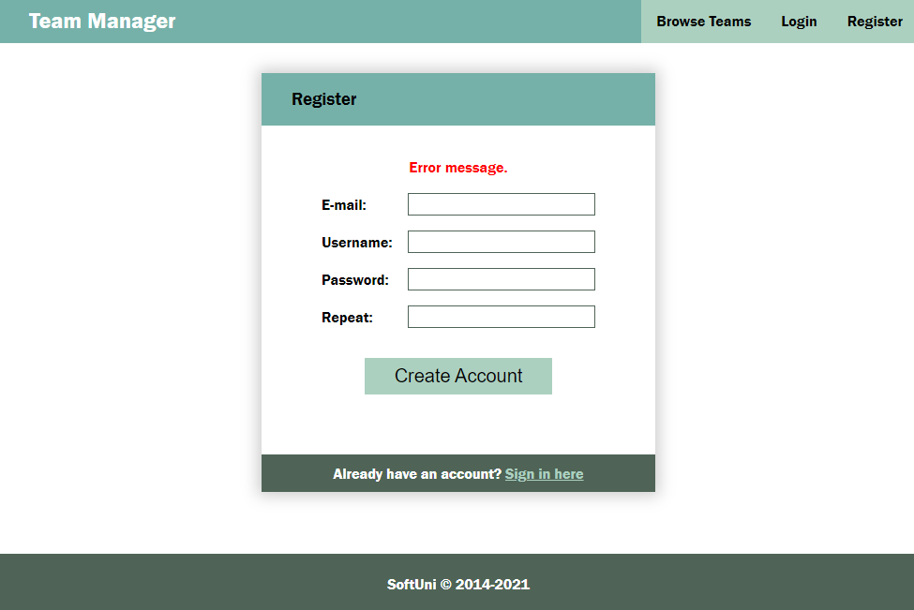
If the registration is successful you can redirect to My Teams page.

Login
If the user already has registration, they may login by using the login form. If there is an error, it should be shown the same way as described for the registration.
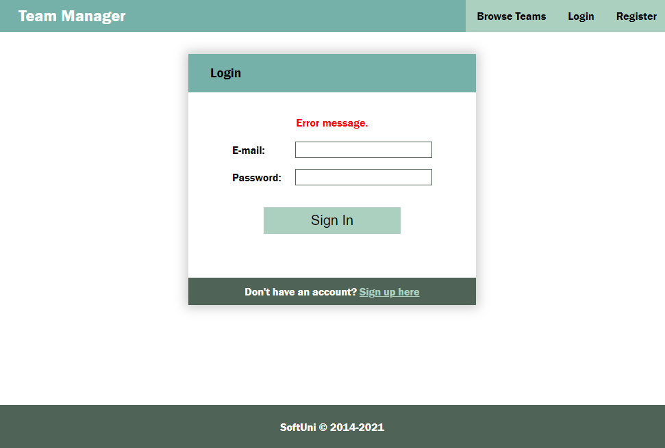
After successful login the user should be redirected to the My Teams page.

Logout
The logged in user can be logged out by clicking the logout button. Write the functionality for this action. After logout redirect to Home page.

New Team
The Create new team page is a form with the following fields and validations:
- name (Team name): required, at least 4 characters,
- logoUrl: required,
- description: required, at least 10 characters
If there is an error by the creation of new team, display the error div with the corresponding message.
After successful creation of team, redirect to "Team Details" page of the new created team.
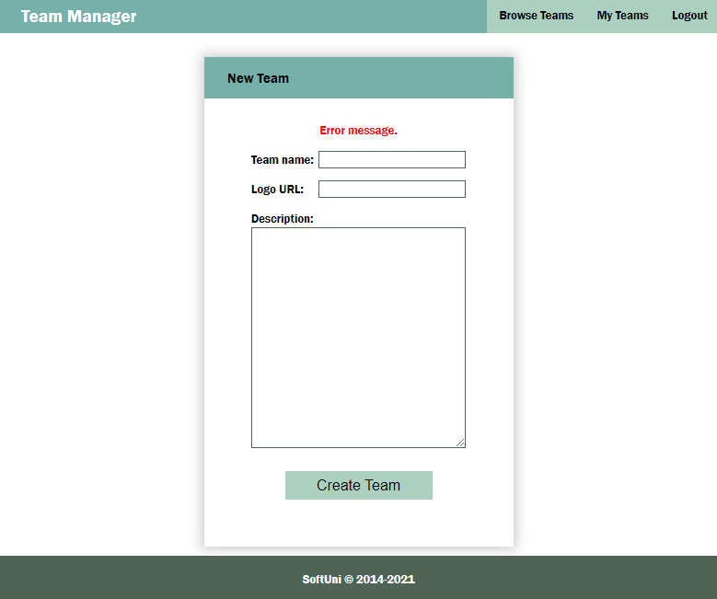
Use the following endpoint (body contains name, imageUrl, description):
POST /data/teams
Note that when a new team is created, the owner is not automatically added as a member by the server – you need to do this on behalf of the user. Once you have obtained the newly created team (returned by the REST service), follow the instructions and endpoints listed in the section Team Details to first send a membership request for the user and then to approve that request.

Edit Team
If the user is the creator of the team, by clicking the "Edit" button in the details form, can see the Edit form. When loaded the form fileds should be filled up with the data of the team. After change and before sending the PUT request a validation should be made. The validation is the same as by creating a team. If error occurs it should be shown in the div with class "error".
After successful edit, redirect to Details page.
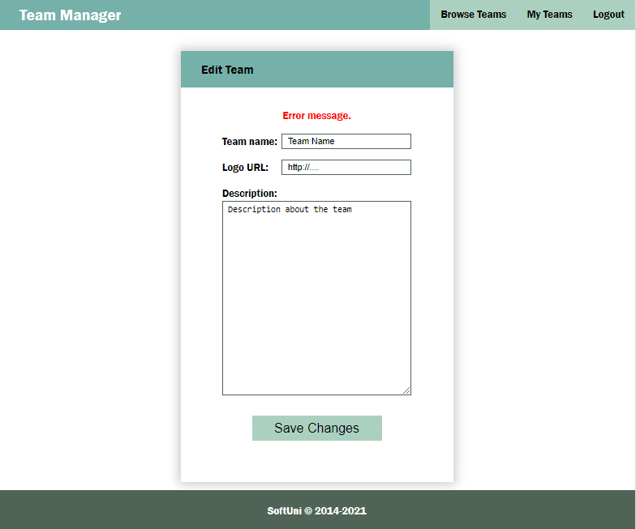
Use the following endpoints:
- Load a selected team for editing:
GET /data/teams/:id
- Edit team:
PUT /data/teams/:id

Team Details
Another view is the Team Details page. It is accessible for logged-in, but also for guest users.
Use the following endpoints to implement page functionality:
- Load information for a single team:
GET /data/teams/:id
- Get a list of all memberships (both members and pending requests):
GET /data/members?where=teamId%3D%22${teamId}%22&load=user%3D_ownerId%3Ausers
This request will return an array of all memberships for the team, which you must them process, depending on the value of the status field. The returned objects will laso have a property user, which contains the user record for the membership. Use the property username of each user to display their record on the page.
Depending to the status of the current user, different actions are available on this page:
- The GUEST users (no user session present) can't see any buttons, but can see the names of the members (the names of the users are the usernames of the registered users).
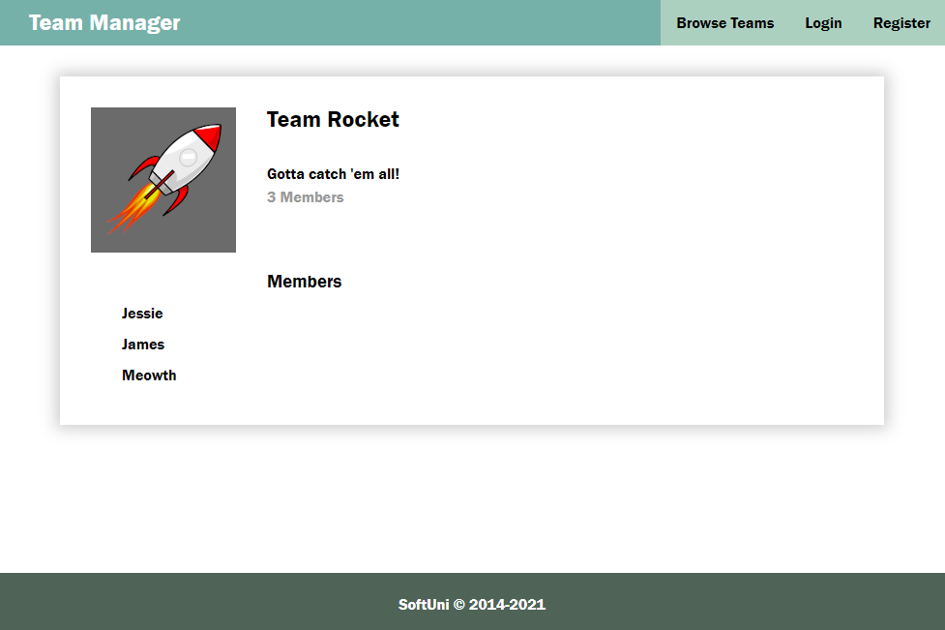

- The owner of the team (current user’s Id matches the _ownerId of the team) can see the "Edit" button, the "Remove from team" button (for all users, except for himself) and a list with pending requests for joining the team (also the "Approve" and "Decline" buttons)
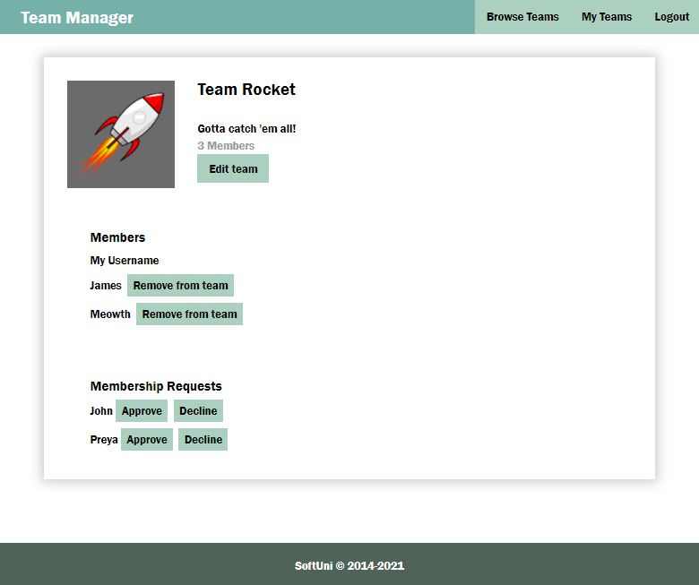
- Logged user, who is not a member of the team (there is no request with _ownerId matching the Id of the current user) can see the list with member names and the button "Join Team"
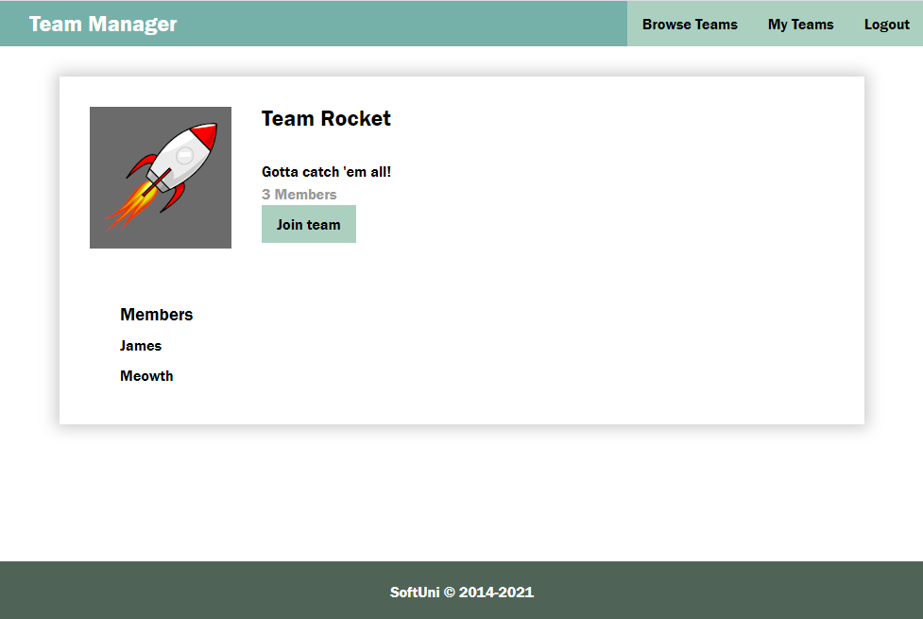

- Logged user with PENDING reques of the team (there is a matching request by _ownerId and it has a status "pending") can see the list with member names and Membership pending and "Cancel request" button.
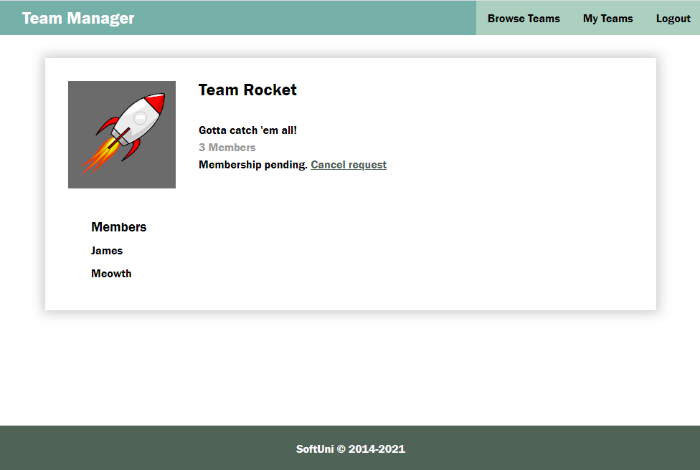
- Logged user, who is MEMBER of the team (there is a matching request by _ownerId and it has a status "member") can see the list with member names of the team and the button "Leave Team". Note that owner of a team should not be able to leave the team.
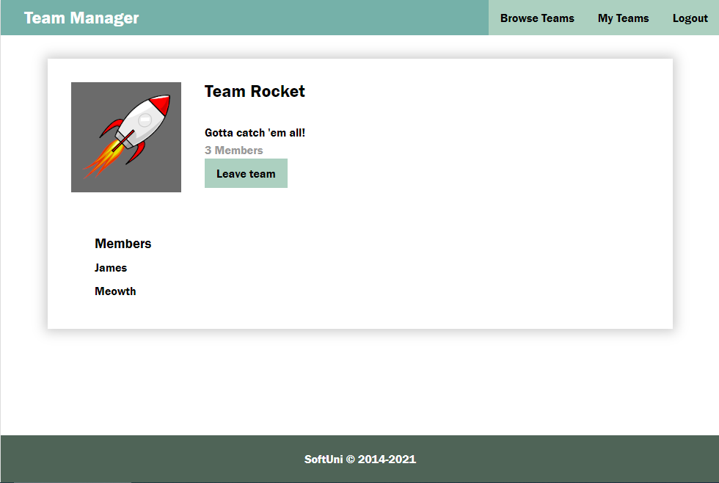
Use the following endpoints for actions:
- Request to become a member (body contains only teamId as property):
POST /data/members
- Approve membership (update request by changing status to "member"):
PUT /data/members/:id
- Cancel request/leave team (user); Decline request/remove member from team (owner):
DELETE /data/members/:id

My Teams
This view displays a list of all teams of which the current user is a member.
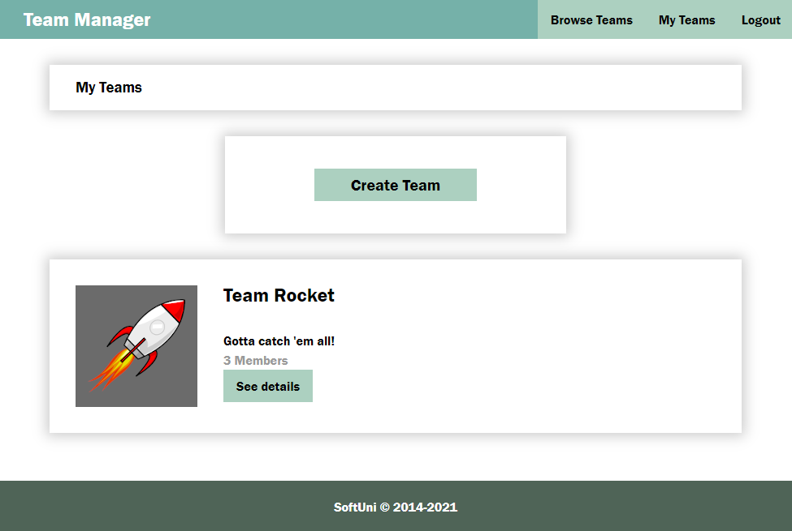
If the logged-in user is not a member or creator of a team, you should show this view with the button "Create Team":
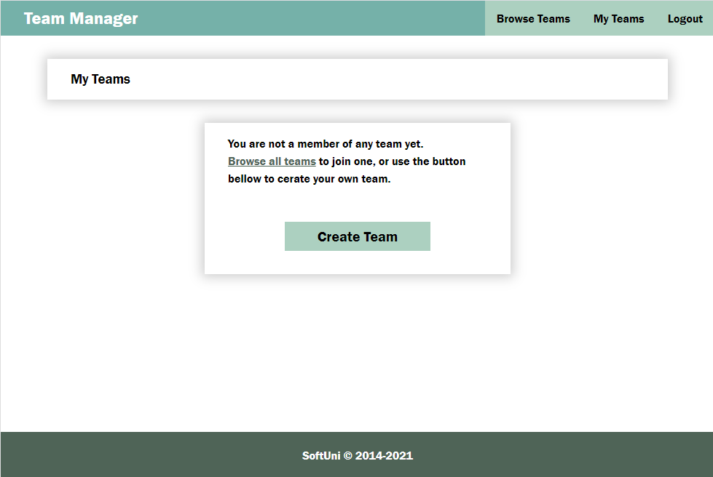
Use the following endpoints:
- List of all teams, where the current user is a member (this should include the owner, if you have followed the instructions to automatically add them after team creation):
GET /data/members?where=_ownerId%3D%22{userId}%22%20AND%20status%3D%22member%22&load=team%3DteamId%3Ateams
This request will return a compound object with information about the membership – you need to use the team property of each of the objects in the returned array to access team information, such as name and _id.
- List of all members in particular teams (unencoded):
GET /data/members?where=teamId IN ("{id1}","{id2}","{id3}",…) AND status="member"
Where {id1}, {id2}, etc. is a list of comma-separated team Ids. Note that every Id must be in double quotes since object Ids are strings. To send this query, use the encodeURIComponent function on the query parameter value (the part after the first equal sign, beginning with teamId).

Modal
An HTML example is included with id "overlay" (initially set to display:none). If there is a need of confirmation or there is an error (not an error in the forms validation) the modal should be shown with the corresponding message and buttons. Usage of this modal is optional.
